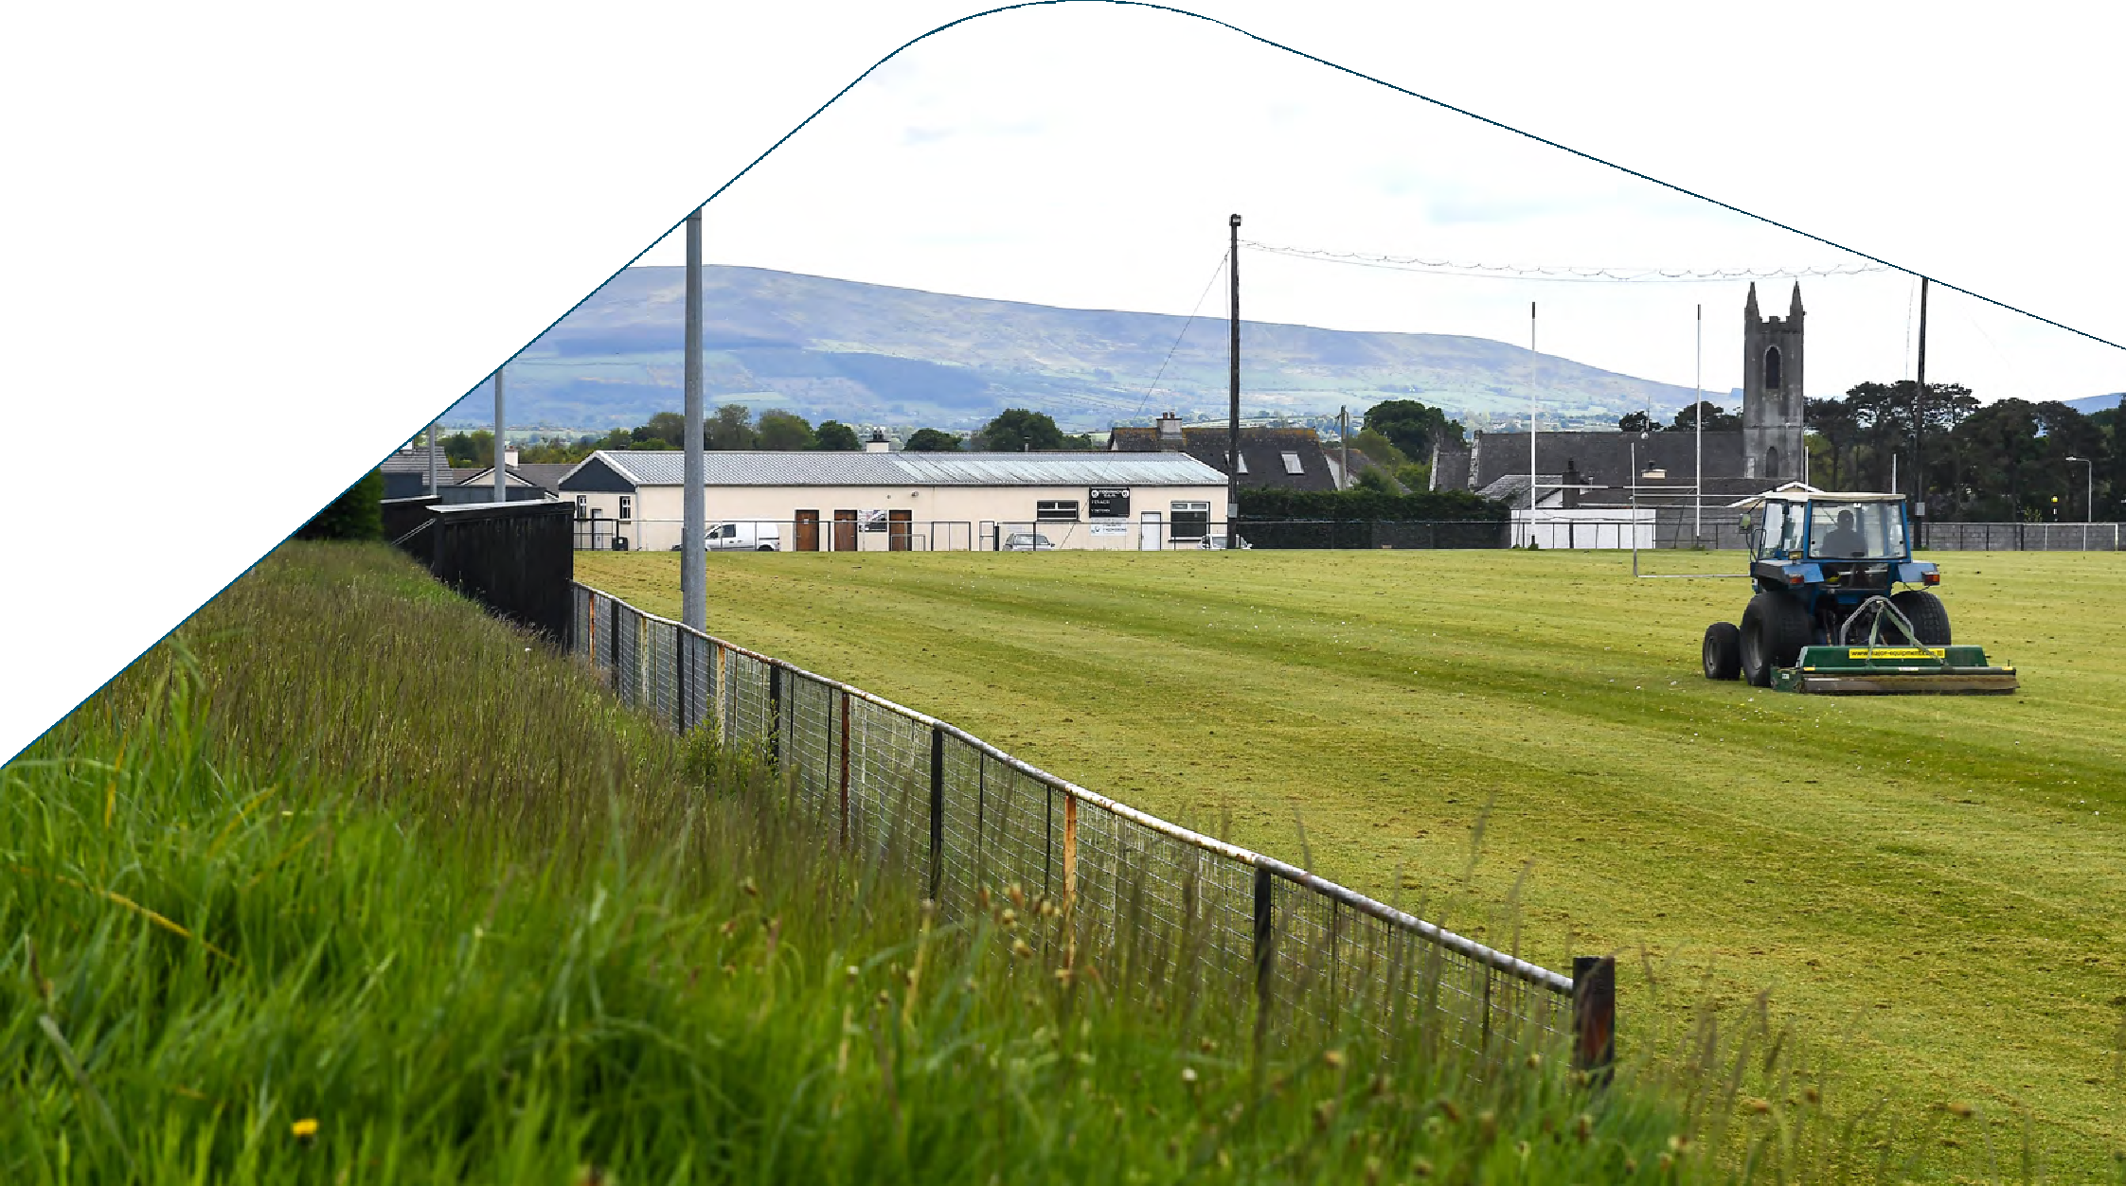

Covid 19 Reopening Facilities

It is important to note that these are recommendations/advice rather than requirements/directives and it is by no means exhaustive as clubs may wish to put additional or site-specific measures in place. Like all other Covid-19 guidance it is also subject to change at any time.

NHSC Guidance on Covid-19 Equipment and Supplies for GAA Clubs
The following is guidance on the procurement of Covid-19 equipment and supplies that may be required to mitigate the risk of Covid-19 in GAA clubs and facilities. Guidance on each of the following categories is subject to change and based on government guidelines. The Consumer Protection Commissioner has released the following guidelines for purchasing PPE, visit guide for business on PPE

Item | Specification & Recommendations
Face Coverings (Disposable Masks) | Advise all staff, volunteers, players, and visitors to wear their own mask when required 2-ply minimum with loops  HSE advice on types of masks can be found on the HSE website
Hand Sanitiser Dispensers/Hand Wash Stations | Consider portable weather-resistant steel dispensers for outdoor use Outdoor hand wash stations would be a cost-effective measure  Wall mounted refillable sanitiser units for indoor use located at key entry and exit points
Hand Sanitiser  Antibacterial Liquid Hand Wash | WHO recommend hand washing is the most effective form of hand hygiene Additional antibacterial liquid hand wash should be made available for all indoor areas Hand sanitiser should have a minimum of 60% alcohol and no more than 80%
Antibacterial disinfectant- surface cleaner | Use disinfectant spray to clean key touch point areas such as training/match equipment and doors. Ensure the spray is listed as killing 99% of bacteria including e-coli and salmonella as well as cold & flu viruses
Signage Outdoor | Signs should be weather resistant for at least 12months  A2 ‘corriboard’ signs (as illustrated below) suitable for outdoor use How to prevent Coronavirus Consider stencilled ground markings and hazard tape for social distancing measures
Signage Indoor | Homemade or printed signs would be sufficient in most indoor areas “How to Handwash” signage in place in bathrooms  “How to Handrub” signage in place next to any hand sanitiser units  “Remember social distancing” signage in place throughout all areas. Use of (black & yellow) tape and vinyl floor stickers to illustrate social distancing measures

Note: Thermometers are not required for clubs but if using one ensure it is a non-contact and CE approved device

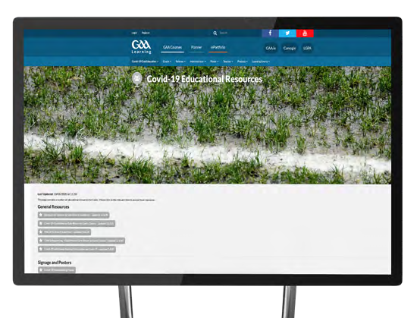
Access to printable GAA branded signage is also available via the GAA learning portal

It is important to note that these are recommendations/advice rather than requirements/directives and it is by no means exhaustive as clubs may wish to put additional or site-specific measures in place. Like all other Covid-19 guidance it is also subject to change at any time.

See here https://learning.gaa.ie/covid19resources

Outdoor Signage Samples Indoor Signage Sample

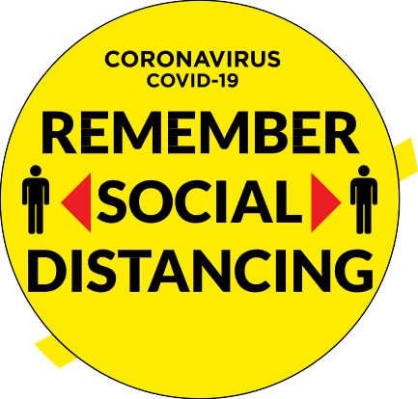
Coronavirus
COVID-19
Help prevent coronavirus
Wash your hands
Cover mouth if coughing or sneezing
Avoid touching your face
Keep surfaces clean
Stop shaking hands and hugging
Keep a safe distance
The virus spreads in sneeze and cough droplets, so regularly taking the above measures helps reduce the chance of it spreading.
Visit HSE.ie
For updated factual information and advice Or call 1850 24 1850
Protection from coronavirus. It’s in our hands.
How to Handrub?
RUB HANDS FOR HAND HYGIENE! WASH HANDS WHEN VISIBLY SOILED
Duration of the entire procedure: 20-30 seconds
1_{a}
1_{b}
Apply a palmful of the product in a cupped hand, covering all surfaces;
Rub hands palm to palm;
3
Right palm over left dorsum with interlaced fingers and vice versa;
Palm to palm with fingers interlaced; Backs of fingers to opposing palms
with fingers interlocked;
6
7
8
Rotational rubbing of left thumb
Rotational rubbing, backwards and Once dry, your hands are safe.
clasped in right palm and vice versa; forwards with clasped fingers of right
hand in left palm and vice versa;
All reasonable precautions have been taken by the World Health Organization to verify the information contained in this document. However, the published material is being distributed without warranty of any kind, either expressed or implied. The responsibility for the interpretation and use of the material lies with the reader. In no event shall the World Health Organization be liable for damages arising from its use.
WHO acknowledges the Hôpitaux Universitaires de Genève (HUG), in particular the members of the Infection Control Programme, for their active participation in developing this material.

May 2009
5
4
2
How to Handwash?
WASH HANDS WHEN VISIBLY SOILED! OTHERWISE, USE HANDRUB
Duration of the entire procedure: 40-60 seconds

0
Wet hands with water;
Apply enough soap to cover all hand surfaces;
Rub hands palm to palm;
3
Right palm over left dorsum with interlaced fingers and vice versa;
Palm to palm with fingers interlaced; Backs of fingers to opposing palms
with fingers interlocked;
6
7
8
Rotational rubbing of left thumb
Rotational rubbing, backwards and
Rinse hands with water;
clasped in right palm and vice versa; forwards with clasped fingers of right
hand in left palm and vice versa;
9
Dry hands thoroughly with a single use towel;
Use towel to turn off faucet;
Your hands are now safe.
All reasonable precautions have been taken by the World Health Organization to verify the information contained in this document. However, the published material is being distributed without warranty of any kind, either expressed or implied. The responsibility for the interpretation and use of the material lies with the reader. In no event shall the World Health Organization be liable for damages arising from its use.
WHO acknowledges the Hôpitaux Universitaires de Genève (HUG), in particular the members of the Infection Control Programme, for their active participation in developing this material.

May 2009
11
10
5
4
2
1

Suppliers of Equipment known to the GAA offering discounts to GAA Units

QUINTESS DENTA LIMITED | Peter Greene | Buy online –  www.quintessdentappe.com/gaa using the password: gaagroup | Quintess Denta are a respected and well-established distributor within the medical supplies and PPE market, based in Fermanagh. The web page we have created specifically for GAA Clubs and counties will be very useful in allowing them easy access to ordering certified quality PPE products.
DBA | Tadhg Cowhig | 087 2105040  tadhg@dbapublishing.ie | WE WILL KEEP IT SIMPLE - Preferred print and publishing partners of the GAA for many decades with a strong national reputation for highest standards, reliability and honesty. WE KNOW WHAT YOU WILL NEED - Thorough understanding of grassroots. We have assessed what clubs require to ensure they are compliant, safe and welcoming.  WE HAVE THE EXPERIENCE - Already involved with supplying reopening packages to local governments, financial organisations, logistics companies.
VIRA HYGIENE | Frank Delargy | www.virahygiene.com  frank@virahygiene.com | Vira Hygiene Ireland offers a range of products, including sanitising stations and liquids, both alcohol and non-alcohol based, all fully certified in both Irish jurisdictions. We offer a range of payment options, from outright purchase to 12 and 24 month rental. Frank Delargy, Sales director of Vira Hygiene in Ireland, is passionate about delivering a best in class solution to GAA clubs and counties across the island, with a strong understanding of the challenges facing clubs as they strive to find the best value solution in the fight against bacteria and enveloped viruses including Coronavirus.
HAVEN HIRE | Audrey Kilgannon | Audrey.Kilgallon@haven.ie info@haven.ie | Haven Hire is a one stop shop for all of your DIY, construction or landscaping requirements. We carry anything from a drill to a 63’ Cherry Picker and everything in between. Visit our website www.haven.ie
PITTMAN TRAFFIC & SAFETY EQUIPMENT | Brendan Pittman | sales@pittman.ie | Pittman Traffic offer a full range of safety equipment for social distancing - specialising in barriers, signage, sanitiser and masks. Celebrating our third year of sponsoring the Kildare Intermediate Football Championship, Pittman have special pricing for GAA clubs nationwide. Visit our website: www.pittman.ie or call us on 059 8630440
CUSPAL | Russell Williams | rwilliams@cuspal.com | With over 30 year experience in signage and graphics and a 20,000 square foot premises in Dublin with 38 staff employed, Cuspal pride ourselves on our customer satisfaction and have a long history of working with repeat clients who have benefited from our expertise in brand awareness, raising your profile and communicating your message clearly and effectively. Our clients include An Post, Bank of Ireland, eir, ESB, 3 and Croke Park, amongst many others, both small and large, national and international.
3 ROCK | John O’Reilly | john@3rockeco.ie | From small projects to nationwide roll outs, all made in our factories. Signage, Joinery and Metal. Nationwide coverage for Delivery or Installation. Innovative development design teams in house.
SHERPACK | Derek Sheridan | derek@sherpack.ie | Sherpack Limited is a family run company for over 40 years. Just like the GAA, we pride ourselves in hard work, dedication and community. Choose Sherpack Ltd for a fast, timely, reliable and seamless delivery for your club.
CUSTODIAN | Alan Brogan | Alan.Brogan@custodian.ie | Custodian has delivered brand care to some of the largest companies in Ireland since 1992. We are trusted for the creation, production, distribution and management of high quality advertising, operational and marketing materials ensuring a consistent message throughout. Whatever the challenge we create highly impactful campaigns that enhance brands and cost-effectively manage the production and placement of marketing assets.
EXACT GROUP NI | D. Cromie | dcromie@exactgroupni.com | Exact Medical, a member of Exact Group, is a precision engineering entity that provides aerospace level solutions to a range of business sectors. With ISO 13485:2016 certification, it is well placed to address pressures associated with running a business in the Covid 19 era, offering an array of hand sanitisation stations, and sanitiser fluid to small to large business owners: no matter what customer footfall. Contact Exact Medical to learn about the sanitisation option that best suits you. www.exactmedical.co.uk and www.exactmedical.ie
CONOR BROWNE | Conor Browne | conorbrownewreaths@hotmail.com | 10% discount GAA2020 www.conorbrownewreaths.com
SKYDRIVE LTD | George Gannon | info@cleanrwithireland.net | Skydrive Ltd is the Irish distributer of worldwide company CleanRwith International Ltd sanitization products, who provide two newly developed products that are designed to be deployed in confined spaces like dressing rooms. Their automated one-shot foggers combined with their hard surface multi-spray can be seen to be the solution to the safe reopening of our changing room facilities
PRINTCOMP | David O’Toole | 01 497 8511  david@printcomp.ie | Printcomp is a busy design studio situated in Rathmines, Dublin. Working with some of Ireland’s most prestigious organisations and companies for over two decades, we have developed a reputation for creating elegant design solutions in print and digital media to meet your budget and on time. If you need any other information on our extensive range of services or would like a quote please contact us today.

