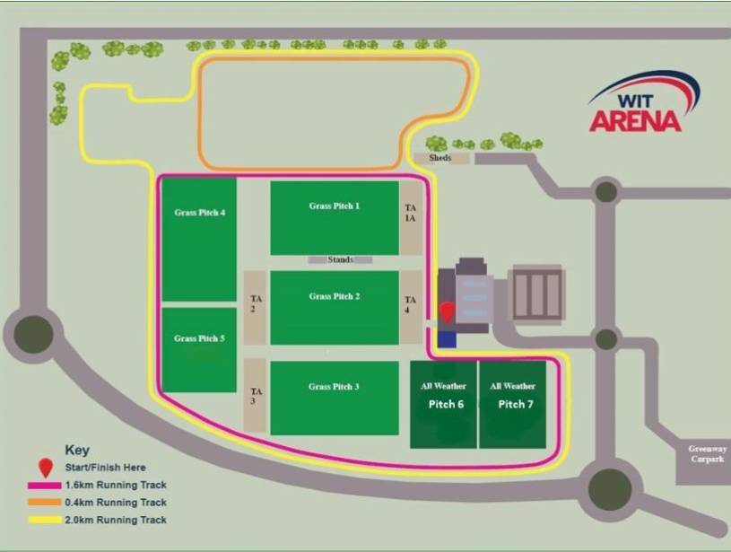

**Renault GAA World Games 2019 Tented Village Legend:**

Renault GAA World Games Tented Village

Renault GAA World Games Pitches 1-7

WIT Arena Building

Mobile Screen